<https://petstore.octoperf.com/actions/Catalog.action>

Referring to the functional flows in the above application prepare the

1) Flow Diagram :- Understanding the basics of anything. How system works at high or detail level  
2) Transition Diagram :- Good when there is an object which changes states  
3) Contextual Diagram :- To connect various system to understand a larger picture like you have taken example how a software interacts with time sheets, employee system  
4) Mind Map :- Create a central topic and you can generate various ideas around it.

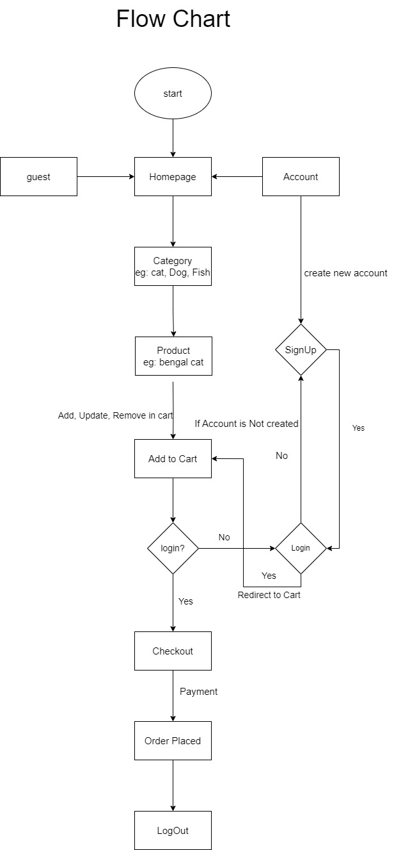

TRANSITION DIAGRAM:

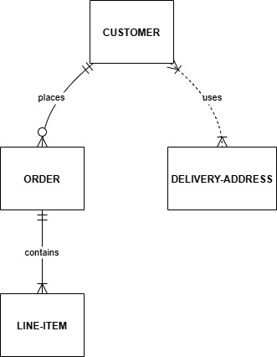

CONTEXTUAL DIAGRAM:

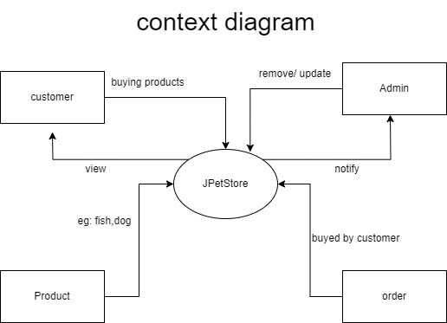

MINDMAP:

